

**课程实验报告**

**课程名称： 物联网通信技术**

**专业班级： 物联网工程1601**

**学 号： Ｕ201614898**

**姓 名： 潘 翔**

**指导教师： 徐 海 银**

**报告日期： 2018.12.28**

**计算机科学与技术学院**

1 节点-节点单播无线通信 1

1.1 实验目的与要求 1

1.2 实验内容 1

1.3 实验过程与结果 1

1.3.1 开发环境 1

1.3.2 BlinkToRadio源程序 2

1.3.3 项目修改 2

1.4 实验结果分析 4

1.5 心得体会与总结 4

2 节点-PC串口通信实验(简单基站版本) 5

2.1 实验目的与要求 5

2.2 实验内容 5

2.2.1 实验涉及内容 5

2.2.2 实验内容要求 5

2.3 实验过程与结果 8

2.3.1 开发环境 8

2.3.2 TestSerial例程 8

2.3.3 BaseStation例程 11

2.3.4 RadioAndSerial程序 13

2.4 实验结果分析 14

2.5 心得体会与总结 16

3 路由转发 17

3.1 实验目的与要求 17

3.2 实验内容 17

3.3 实验过程与结果 18

3.3.1 开发环境 18

3.3.2 RadioAndSerial项目 18

3.3.3 BlinkToRadio项目 18

3.4 实验结果分析 20

3.5 心得体会与总结 21

参考文献 23

附录 24

Lab1 25

BlinkToRadio.h 25

BlinkToRadioAppC.nc 25

BlinkToRadioC.nc 28

Makefile 32

Lab2 33

BlinkToRadio.h 33

BlinkToRadioAppC.nc 33

BlinkToRadioC.nc 36

RadioAndSerial.h 40

RadioAndSerial.java 41

RadioAndSerialAppC.nc 44

Makefile 51

Lab3 53

BlinkToRadio.h 53

BlinkToRadioAppC.nc 53

BlinkToRadioC.nc 56

# 节点-节点单播无线通信

## 实验目的与要求

本实验介绍了如何在TinyOS上进行节点与节点之间的无线通信。通过这个实验，熟悉通信相关的组件及接口以及如何以单播的方式发送和接收消息。

根据提供的例子程序，详细了解程序结构，并尝试进行程序的修改运行

1. 熟悉TinyOS无线通信的接口和通信流程；
2. 修改例子程序并测试运行。

## 实验内容

1. 消息发送
2. 消息接收

实验要求说明：

实现类似跑马灯的效果，两个节点都维护计数值counter，初始值为1。节 点1每隔1秒发送计数值到节点2 ,节点2每隔1秒发送自身计数值+ 1到节点 1.。节点1和节点2均接收对方发送的计数值，收到后更新counter，用LED灯显示counter的末三位。

效果：

节点1,节点2都开着的时候，节点1和节点2的LED灯显示的值每隔1秒通增1。此时按住其中一个节点的RESET，另外一个节点的显示将不会停住不再变化，放开之后，又重新从1开始计数。提示：需要分辨节点的编号以发送不同的计数值。

## 实验过程与结果

### 开发环境

OS： Manjaro 18.0.2 Illyria(Arch-Based Distribution)

Kernel: x86_64 Linux 4.20.0-1-MANJARO

TinyOS： TinyOS(Make Version 3.0.0)

GCC: gcc (GCC) 7.4.1

nescc: 1.3.6

Text Editor: VisualStudio Code(1.30.1 x64)

### BlinkToRadio源程序



图1-1 BlinkToRadio源程序

TinyOS官方提供了系列源程序与tutorials目录下供学习。包括基本的串口程序，无线程序和传感器程序。

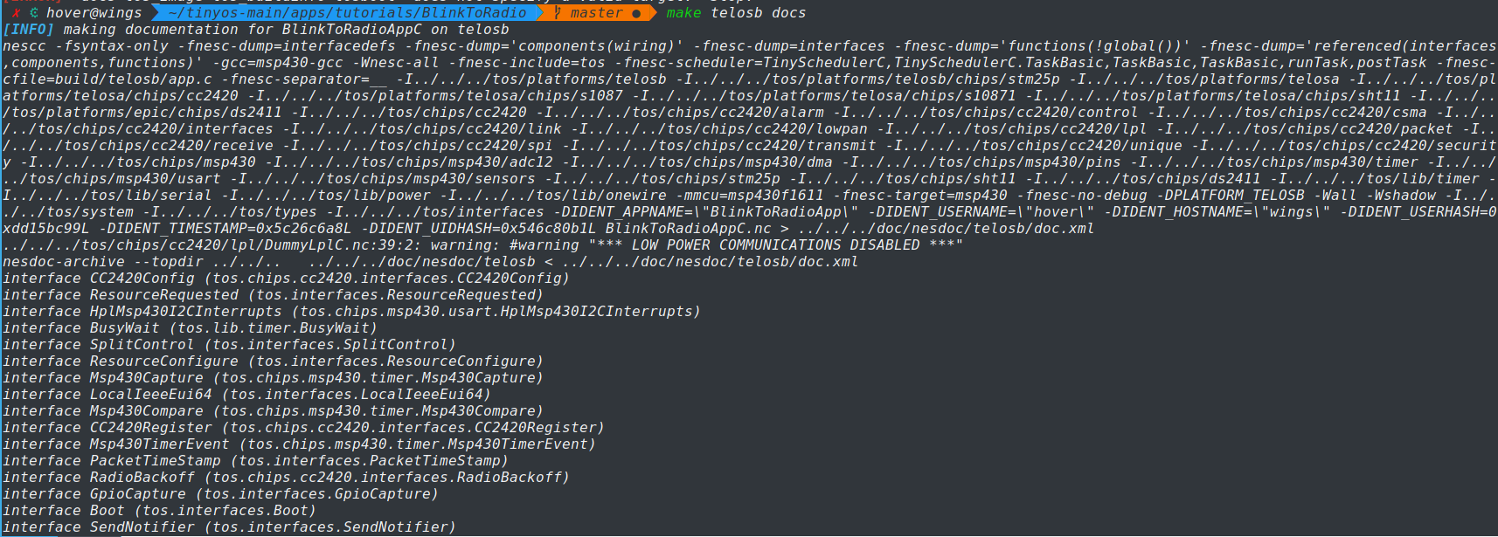

图1-2 生成文档图

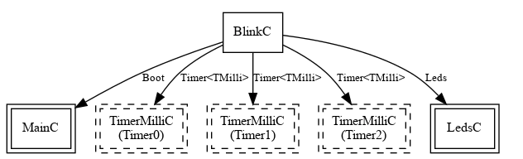

图1-3 代码结构图

整个tiny-os架构采用组件式，故相应的代码结构利于分析，在原程序中，利用Timer进行Task定时，利用Led进行相应的任务响应显示。

### 项目修改

1. Makefile文件

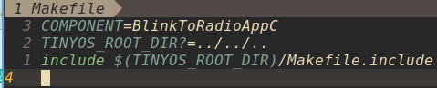

图1-4 源程序Makefile文件

由于采用最新的Make Version 3.0，而不是采用原有2.1.2中的Make系统，没有了TINYOSROOT，TINYOSHOME等环境变量，故在每一个项目中需要修改相应的TINYOS_ROOT_DIR。为了方便，可以采用系统编写环境变量然后统一使用该环境变量的方法，此处，为了不污染系统环境变量，直接使用绝对路径赋值，当发生源码拷贝时，注意修改。

为了实现单播，需要指定信道，否则默认为广播模式。

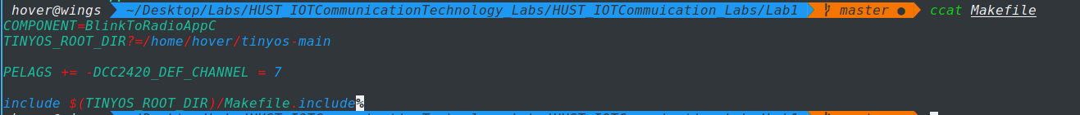

图1-5 修改后Makefile文件

1. 项目文件

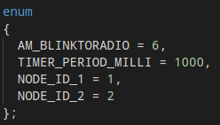

图1-6 指定节点编号及时延

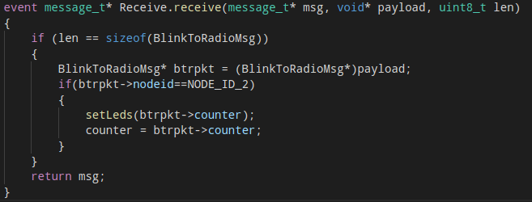

图1-7 指定NODE1仅仅接受的NODE2报文

1. 节点烧入

程序开发完成后将程序烧录进两台不同的节点，一台ID为1，另一台为2，而后观察实验现象。

## 实验结果分析

节点1,节点2都开着的时候，节点1和节点2的LED灯显示的值每隔一秒递增1，节点1和节点2的计数值交替显示。按住其中一个节点的RESERT，另外一个节点的显示将会停住不再变化，放开后又重新从1开始计数，表明两个节点根据对方节点的counter值维护自身的counter值。

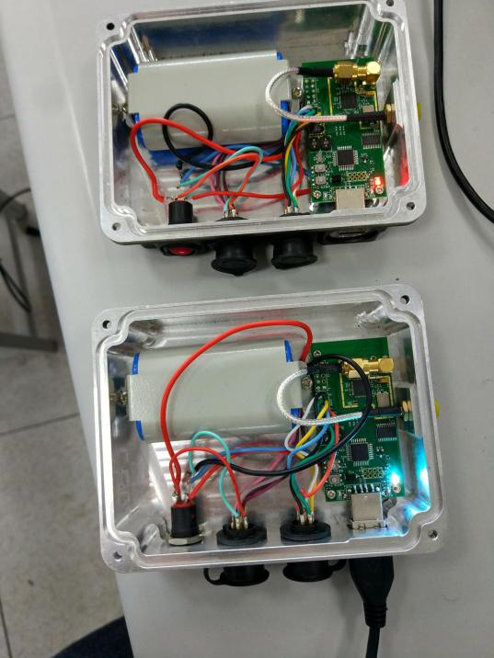

图1-8 无线单播测试图

## 心得体会与总结

因为去年的时候在进行TinyOS实验时，已经尝试了BaseStation等实验，故实验较为简单，此次实验采用Make Version 3编译系统，其中可以清晰的看到TinyOS各代码段数据段所占用的大小，故能够更加的体会到TinyOS为静态系统，在拷入节点的时候已经完成完全确定，这样的特性，在进行大规模拷贝和在线更新的时候具有一定的优势。

# 节点-PC串口通信实验(简单基站版本)

## 实验目的与要求

本实验的目的是实现节点和 PC 间的串口双向通讯，通过串口连接，从网络收集其他节点的数据，也可以发送数据或者命令到节点，因此，串口通信编程是无线传感器网络中的重要内容。

根据例子提供的例子程序，详细了解程序结构，并尝试进行程序的修改运行；

具体实验要求如下：

1. 学会使用串口通信相关的接口函数，实现串口通信。
2. 修改BlinkToRadio程序，添加串口收发，实现一个简单的基站功能。
3. 了解串口双向通信的方法，学会使用mig工具以及SerialForwarder。

## 实验内容

### 实验涉及内容

1. TeatSerial例子程序
2. 基站程序示例
3. MIG及数据包对象
4. SerialForwarder和其他数据包源
5. mote节点向串口发送数据包
6. PC写串口

### 实验内容要求

1. 修改 BlinkToRadio 程序实现简单的基站程序 RadioAndSerial．使得当RadioAndSerial 接收到无线数据包时 Led2 闪烁，并将数据包转发到串口；当串口接收到数据包时，Led0 闪烁，并将数据包转发到无线模块；
2. 使用 mig 创建 BlinkToRadioMsg 的 java 对象，BlinkToRadio 发送的消息由 RadioAndSerial 接收并转发到串口，然后使用 MsgReader 读取 BlinkToRadioMsg 对象，展示接收到的数据。
3. 扩展要求：实现BlinkToRadio.java，进行PC和串口之间的双向通信，从而实现利用PC发送消息控制BlinkToRadio节点Led灯的闪烁。

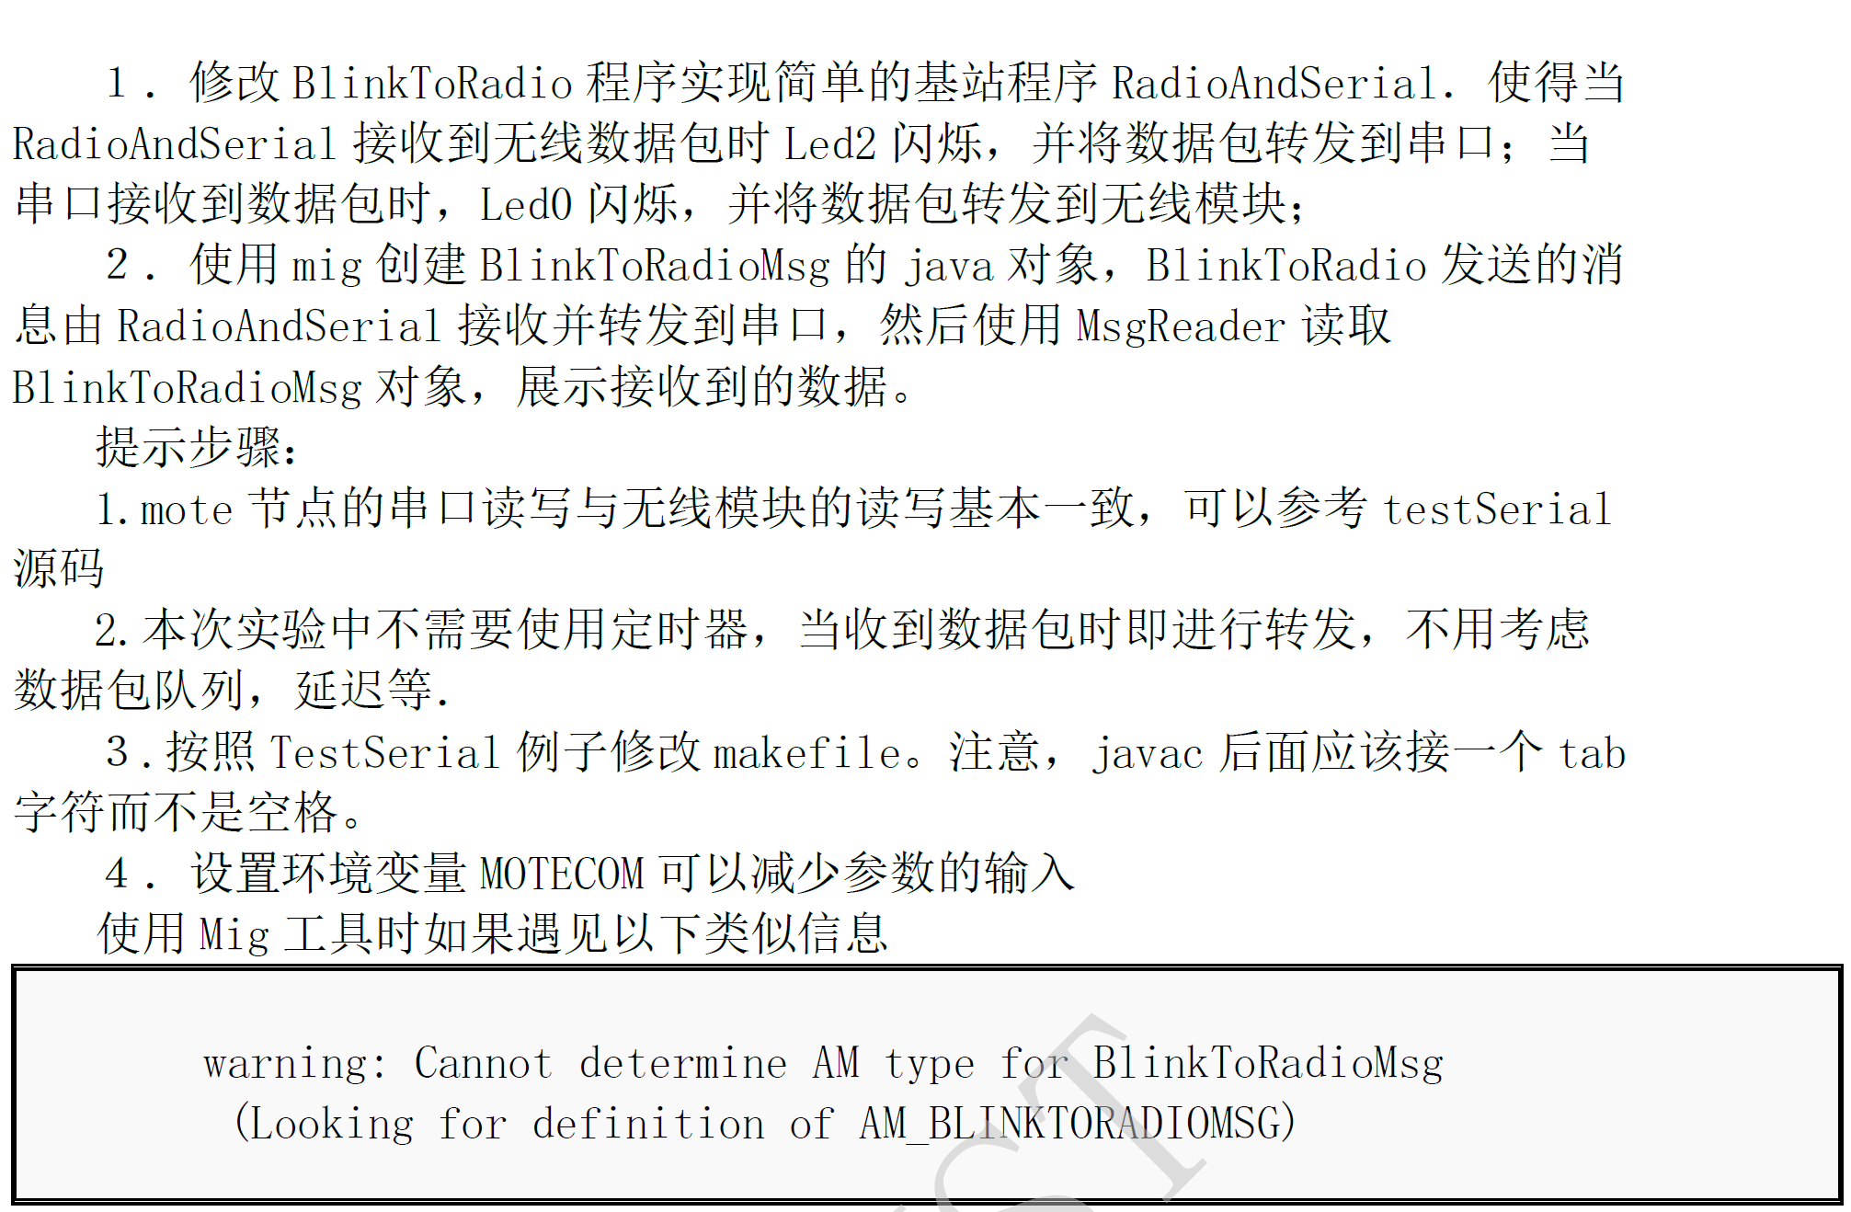



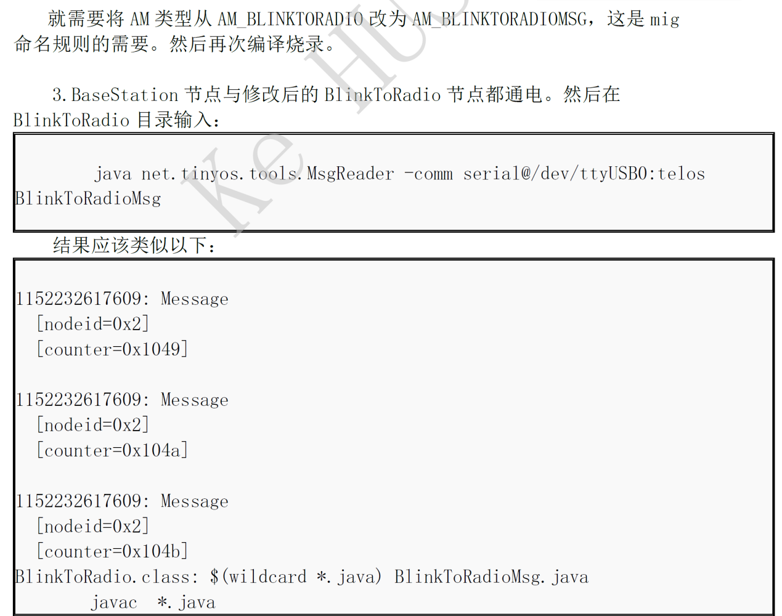

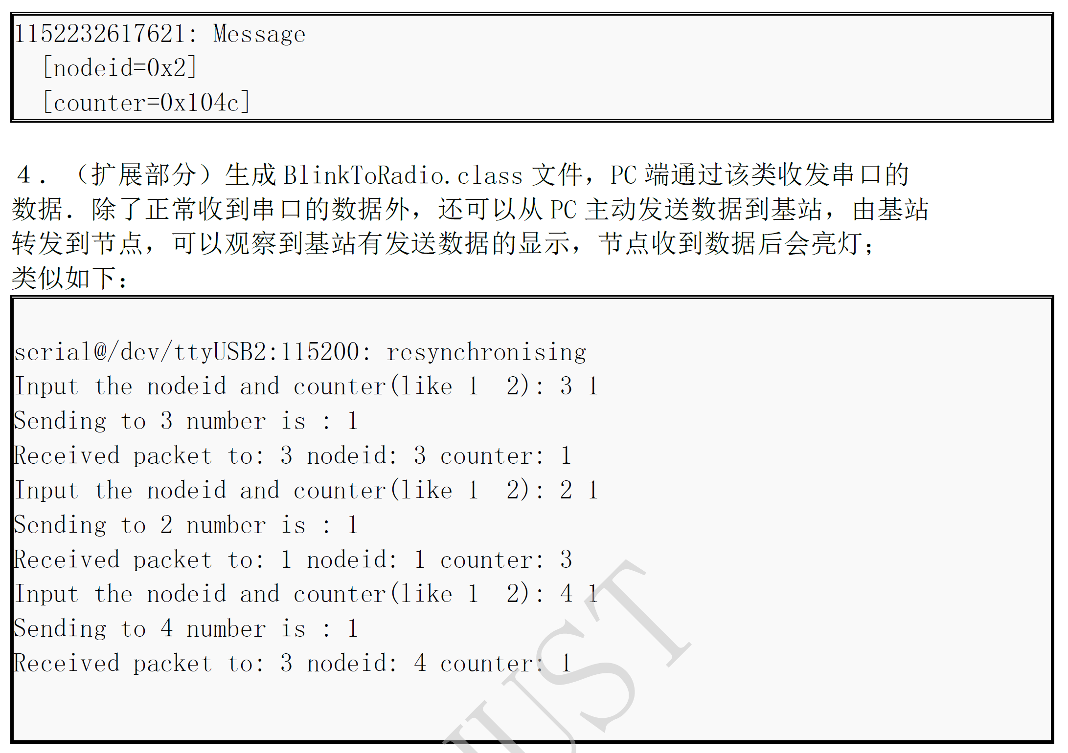



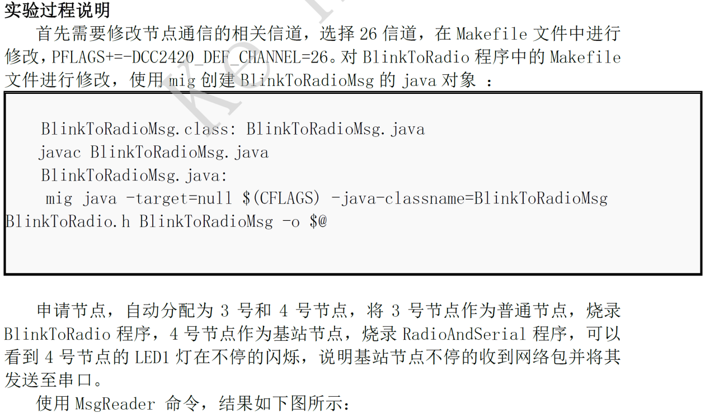

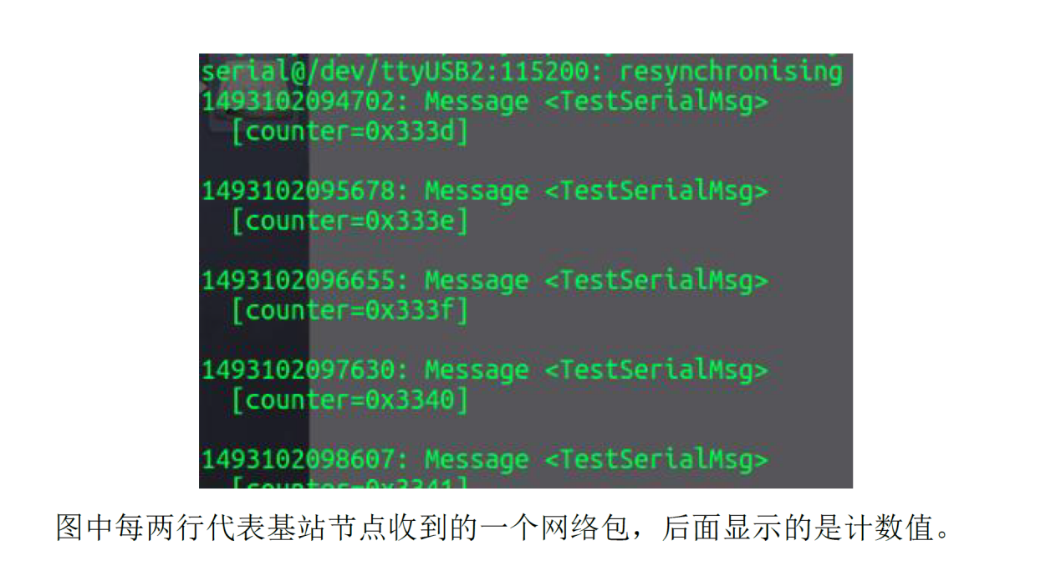

## 实验过程与结果

### 开发环境

OS： Manjaro 18.0.2 Illyria(Arch-Based Distribution)

Kernel: x86_64 Linux 4.20.0-1-MANJARO

TinyOS： TinyOS(Make Version 3.0.0)

GCC: gcc (GCC) 7.4.1

nescc: 1.3.6

Text Editor: VisualStudio Code(1.30.1 x64)

### TestSerial例程

1. 例程分析

在系统Test目录下面有TinyOS的测试程序，并提供了接口测试，此处进行TestSerial



图2-1 TestSerial目录

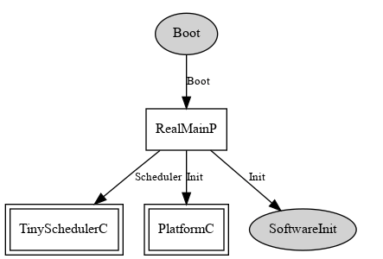

图2-2 TinyOS程序结构

系统启动调用Boot进行启动，然后初始化PlatformC进行配置初始化，然后启动TinySchedulerC进行任务监听

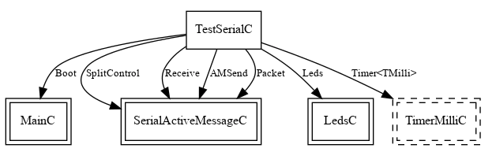

图2-3 TestSerial项目结构

TestSerial接受到消息(可以来自于定时器或者无线消息接受)之后调用SerialActiveMessageC组件进行Task制定，从而完成类似中断机制的消息传送

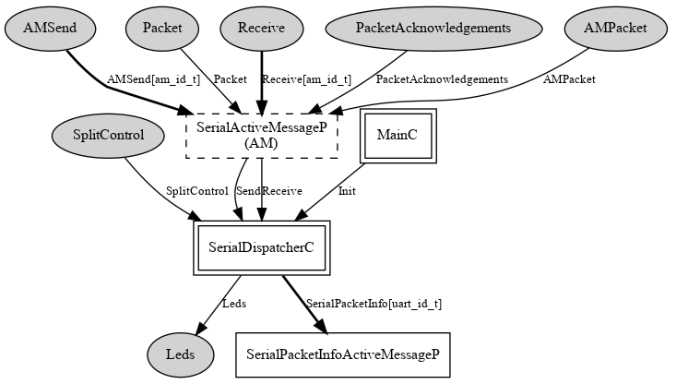

图2-4 SerialActiveMessageC组件配置

利用SerialDispatcherC进行报文发送和LED灯设置

1. 例程烧录
   1. 编译烧录程序：

make telosb install /dev/ttyUSB0

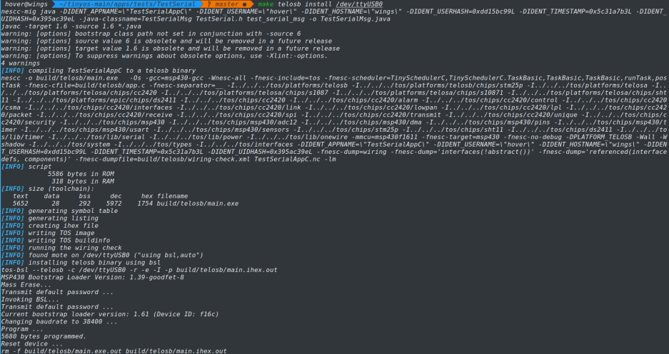

图2-5 TestSerial拷贝

* 1. PC端串口信息接受程序(Java Verision)：

java TestSerial -comm serial@/dev/ttyUSB0:telosb

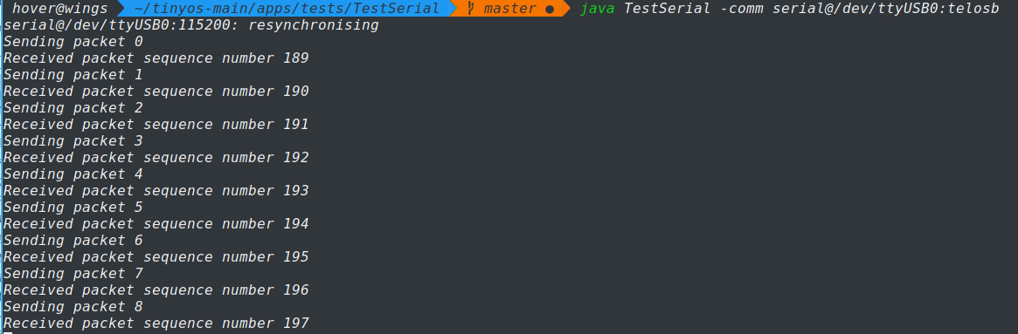

图2-6 TestSerial PC端串口程序输出

可以看到输出seq号和相应的报文解析

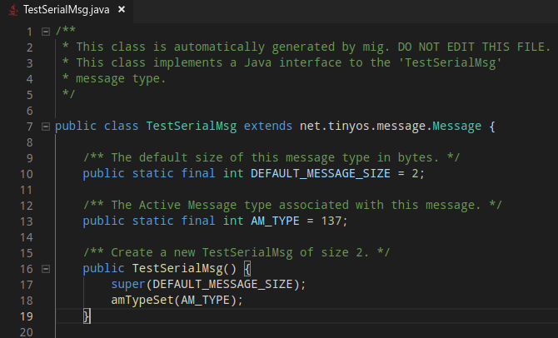

图2-7 MIG生成的报文java文件

此时mig工具会生成对应的报文格式的java描述

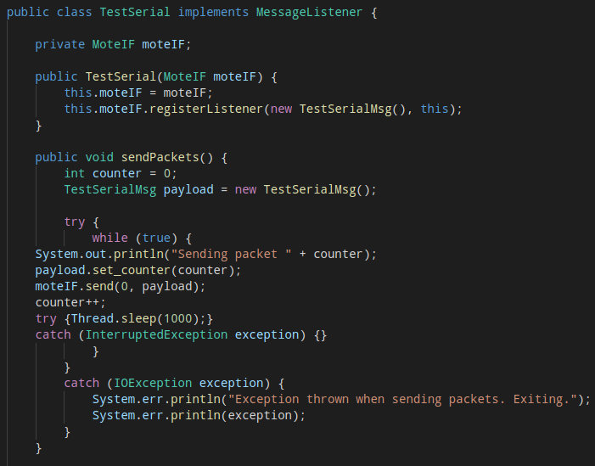

图2-8 报文解析java文件

利用报文解析的java文件进行报文解析并输出，之后可以对报文解析程序进行相应的修改。

TinyOS提供了多套报文解析工具，其中有Java Version和Python Version，只要解析程序能够按照特定的格式进行解析就可以了获取数据，这和通常网络中的协议报文规定语法语义类似。

### BaseStation例程

1. 例程分析



图2-9 BaseStation目录

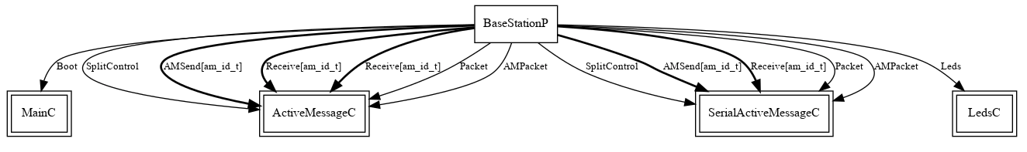

图2-10 BaseStation项目结构

同样录用MainC进行Boot然后调用ActiveMessageC进行相应的消息处理，无线消息的发送和接受，利用SerialActiveMessageC进行相应的有线(串口)信息处理，利用LED进行状态的反馈。

完成如下功能：

1. 在串行链路上，BaseStation发送和接收简单的活动消息（不是特定 的无线数据包）：
2. 在无线电链路上，它发送无线电活动消息，其格式取决于所使用的 网络堆栈。 BaseStation会将其编译后的组ID复制到从串行链路发 送到无线电的消息，并过滤掉不包含该组ID的传入无线电消息。
3. BaseStation包括两个方向的队列，保证一旦消息进入队列，它将最 终离开另一个接口。 队列允许BaseStation处理负载峰值。仅当该消 息成功排入以传送到无线电链路时，BaseStation才会确认通过串行 链路到达的消息。

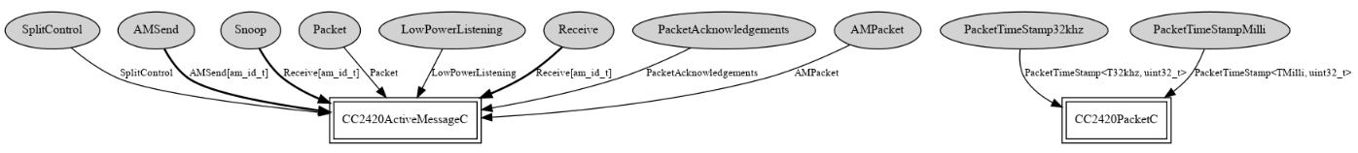

图2-11 ActiveMessageC组件配置图

此处调用相应的接口进行请问消息的处理分组和发送，调用TimeStamp进行报文的时间戳处理。

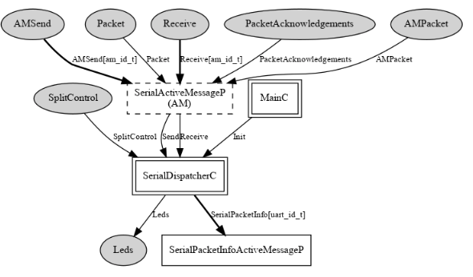

图2-12 SerialActiveMessageC组件配置

SerialActiveMessageP向无线模块提供发送和接受接口，向串口模块提供报文的发送和接受状态，以及Task唤醒。

1. 编译烧录

如图左为BaseStation节点，节点LED不断闪烁，表示接受到报文

右为BlinkToRadio节点

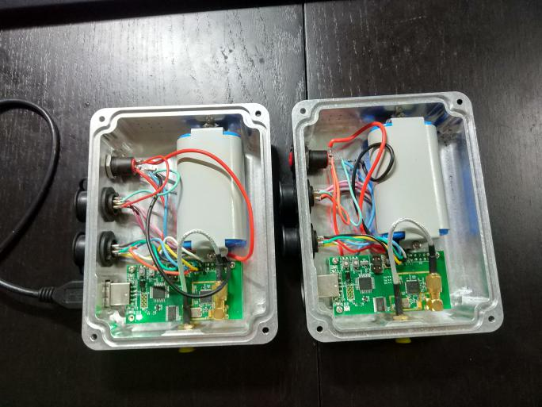

图2-13 BaseStation烧录结果

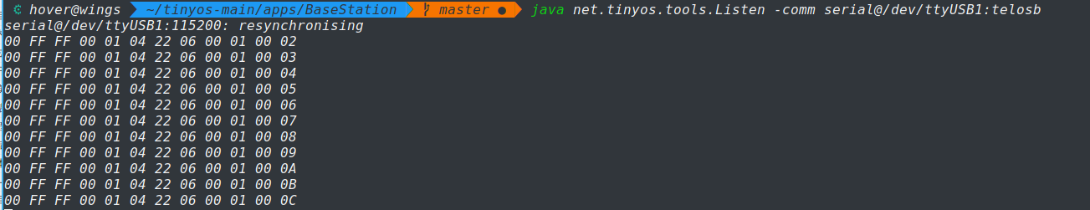

图2-14 PC串口报文解析

### RadioAndSerial程序

修改BlinkToRadio程序

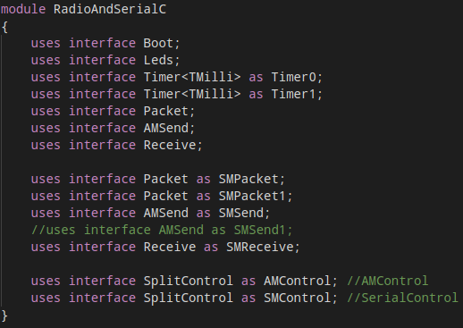

图2-15 RadioAndSerial组件配置

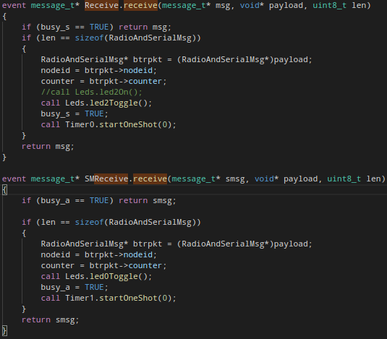

图2-16 串口和无线模块接受消息处理函数

## 实验结果分析

实验结果：烧录终端节点和基站节点，在基站节点程序目录下输入命令java BlinkToRadio –comm serial@/dev/ttyUSB0:telos，按照提示输入一组数据，如图2-4所示，即数据包的目的节点为3，counter值为1，然后计算机通过串口收到来自节点3的消息，可知基站节点实现了双向通信。

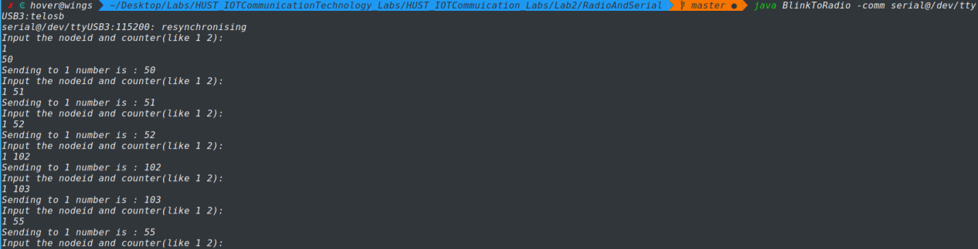

图2-17 PC端口发送消息

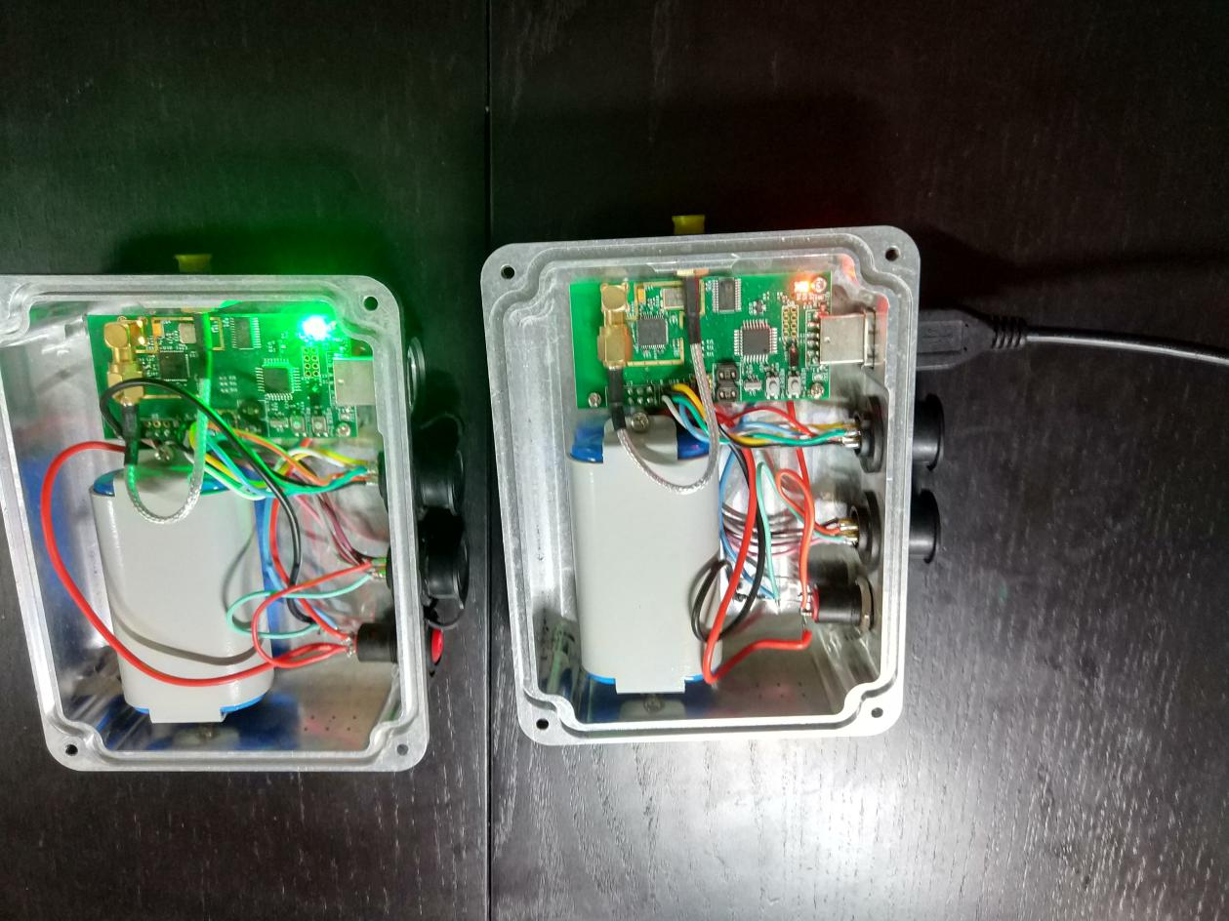

图2-18 PC端口发送消息

红灯为基站发送消息，绿灯为节点接受消息。

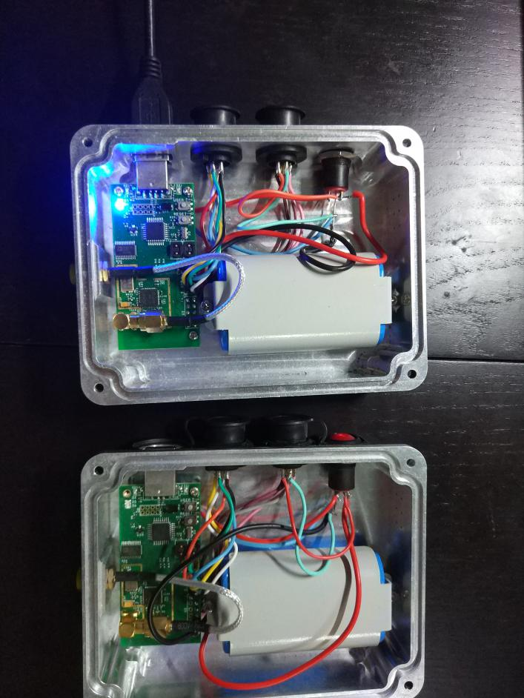

图2-19 接站接受消息

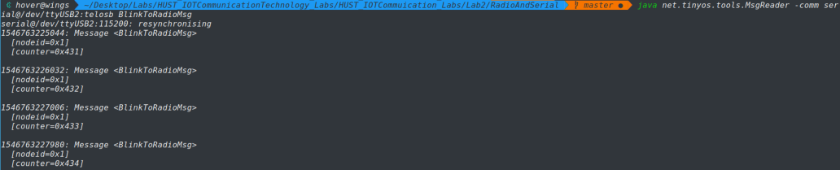

图2-20 PC端口监听消息

由实验现象可以看出基站节点实现了从无线转发到串口以及从串口转发到无线的功能，实现了节点-串口双向通信。

## 心得体会与总结

1. 实验过程中对TinyOS无线组件进行了熟悉
2. 尝试采用两个基站互发消息，此时基站的处理程序直接将消息传给串口，从而可以实现两个PC端的无线通信
3. 在烧录节点时记得查看设备号，避免设备弄混，每一次插拔设备，tty值会加1
4. 因为未提供Debug工具，故只能靠信号灯状态进行判断，实验过程中，出现节点电量较低而无法正常通信的状况，可以将两个节点靠近从而实现通信，在TinyOS组件中提供了天线，也可以增加通信距离。

# 路由转发

## 实验目的与要求

本实验的目的是实现节点和节点间的无线通讯和路由转发,可以使用串口发送消息到基站(指定编号为1的节点为基站),然后转发到指定节点,或者从某个节点定时发送数据,经过固定路径可以转发到基站节点,通过简单的静态路由实验了解无线传感网络的数据路由过程和传感器数据采集过程。

## 实验内容

根据修改实验二的程序 RadioAndSerial,添加静态路由转发功能,具体要求:

1. 节点之间通过单播的方式收发数据;
2. 节点路由方式为:目标节点编号大于自身节点编号的,将数据转发到编号为自身节点编号+1的节点,目标节点编号小于自身节点编号的,转发到编号自身节点编号-1的节点,节点只能直接与相邻编号的节点通讯,即数据只能在相邻节点之间转发。
3. 中继节点的 LED 显示目标节点的编号,停留时间为1s, 目标节点 LED显示计数值,停留时间为 3s, 数据包只转发一次,不进行重复发送,数据到达目标节点后计数值改为原来的计数值加上该节点的节点编号,沿原路径返回到基站;
4. 指定编号为1的节点为基站,基站进行串口读写为广播方式,如果基站节点收到数据,目标节点为自身时将数据发送到串口,否则发送到无线模块;

首先需要修改节点通信的相关信道,选择 26 信道,在 Makefile 文件中进行修改 , PFLAGS+=-DCC2420_DEF_CHANNEL=26 。 对 BlinkToRadio 程序中的Makefile 文件进行修改,使用 mig 创建 BlinkToRadioMsg 的 java对象 :

BlinkToRadioMsg.class: BlinkToRadioMsg.java

javac BlinkToRadioMsg.java

BlinkToRadioMsg.java:

mig java -target=null $(CFLAGS) -java-classname=BlinkToRadioMsg

BlinkToRadio.h BlinkToRadioMsg -o $@

1号节点作为基站节点,2、3号为普通节点,可以通过串口和 LED 清楚的看到整个通信转发过程。

## 实验过程与结果

### 开发环境

OS： Manjaro 18.0.2 Illyria(Arch-Based Distribution)

Kernel: x86_64 Linux 4.20.0-1-MANJARO

TinyOS： TinyOS(Make Version 3.0.0)

GCC: gcc (GCC) 7.4.1

nescc: 1.3.6

Text Editor: VisualStudio Code(1.30.1 x64)

### RadioAndSerial项目

1. 项目分析

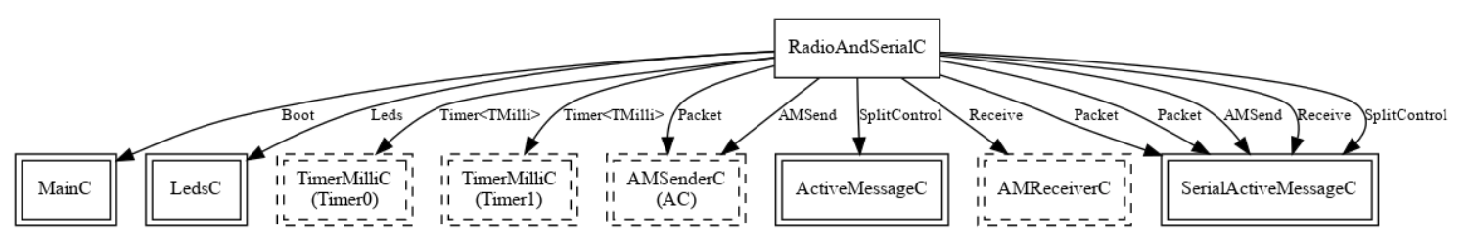

图3-1 RadioAndSerial项目架构

利用Lab2中的RadioAndSerial程序，进行报文的发送和接受，利用指示灯进行状态制定，利用串口通讯工具进行报文的目的地制定，此时地址等同于节点IP。

在TinyOS中提供了一个映射工具，可以将计算机上的端口映射到TinyOS串口，从而可以实现不同网络之间的互联(internet和zigbee网络),互联网发送的报文直接发送到pc相对应的端口，工具进行报文拆解转换成TinyOS通过串口转发给TinyOS结点。

### BlinkToRadio项目

1. 项目架构

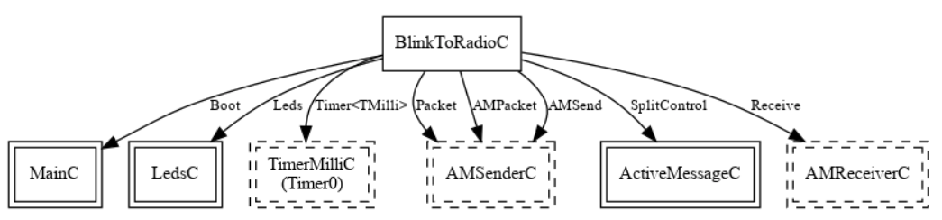

图3-2 BlinkToRadio项目架构

整个项目的逻辑并未改变，只不过对于接受报文的Task进行了改变不再仅仅是触发LED，而是修改下一跳结点的ID,从而实现静态路由，在这一步我们可以看到需要进行报文解析和报文封装过程，同有线网络的路由层次从物理层到网络层再到物理层的过程类似，不过TinyOS报文较为简短，且无多层次，故解析报文并不十分耗能。

1. 路由转发逻辑

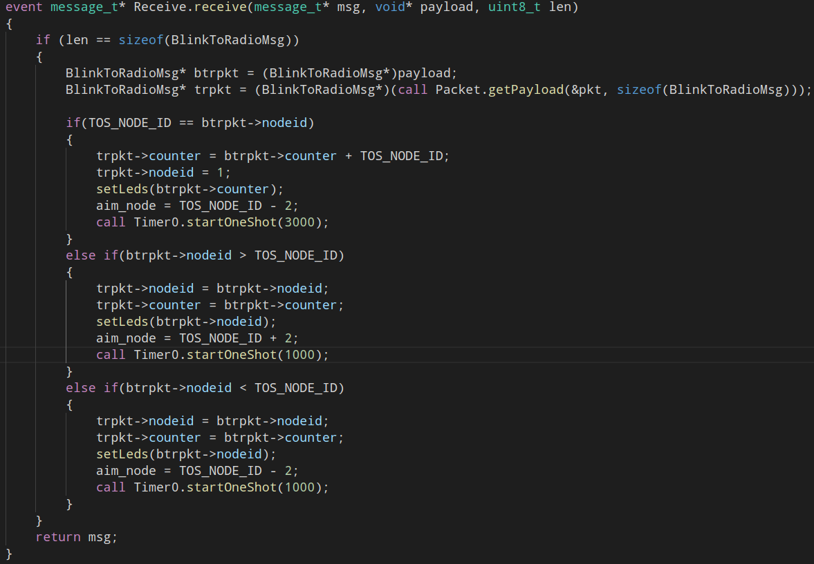

图3-3 接受报文并转发逻辑

基站节点nodeid为1，如果接受节点为目标节点，则发送目标节点为基站的反馈报文，如果目标节点大于自身节点编号，下一跳节点编号加2

如果目标节点小于自身节点编号，下一跳节点编号减少2

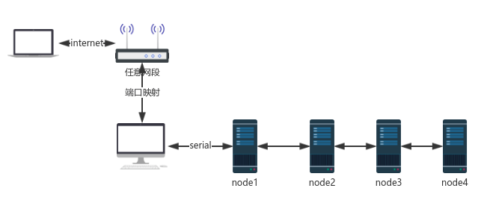

图3-4 TinyOS网络架构图

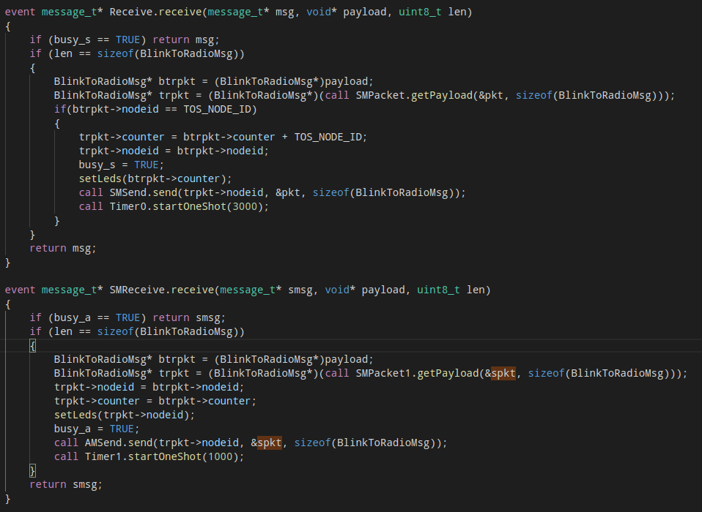

图3-5 基站转发逻辑

## 实验结果分析

从左到右依次为4,3,2,1(基站)节点

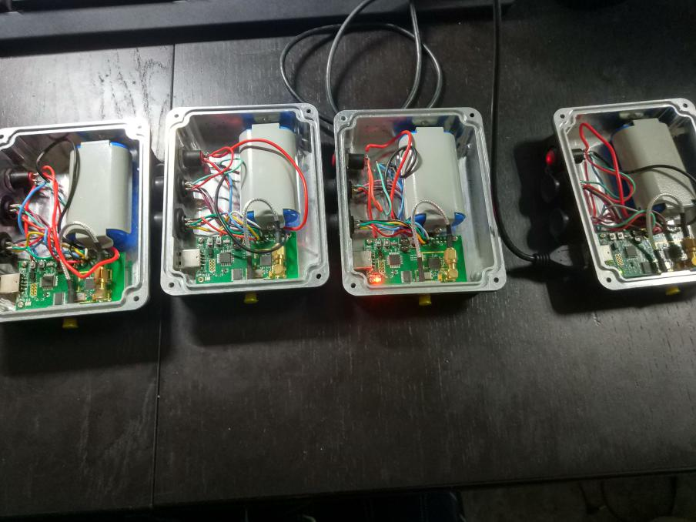

图3-6 发送给2号节点

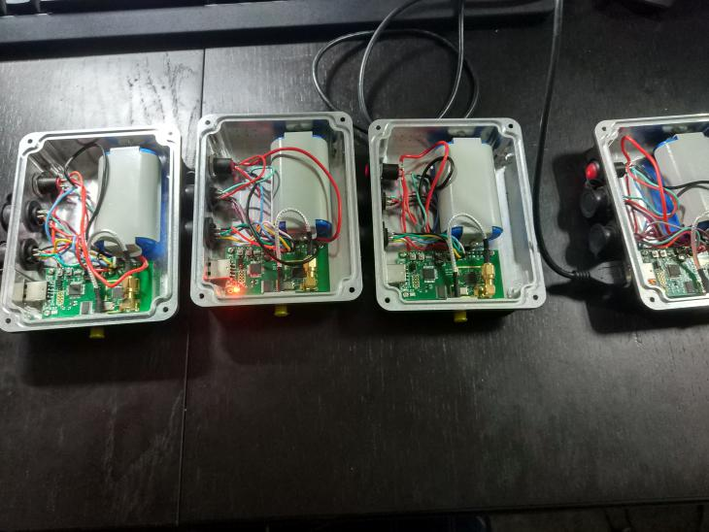

图3-7 发送给3号节点

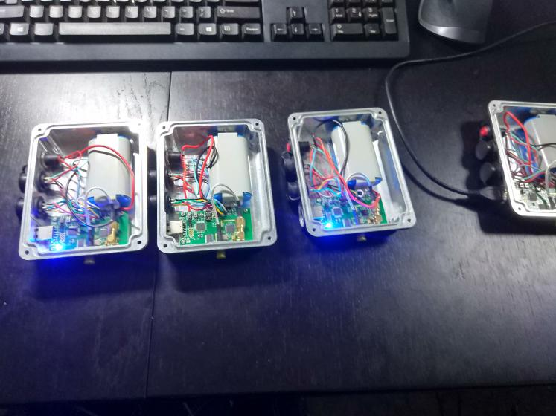

图3-8 发送给4号节点

我们可以看到在二号结点处进行了一次中继。

## 心得体会与总结

1. 由于实验的要求，此处定时器仅仅作为灯的延时而并未作为任务的延时，在接收到消息之后，对于报文进行解析打包然后发送，而不是在一个灯定时之后进行发送。TinyOS的TASK可以定时执行也可以延时执行
2. 可以看到，在进行长距离通信的时候TinyOS在无天线的情况下较弱，必须距离较近，且节点电量对于通信能力有较大影响。
3. 实验过程中，因为插拔导致ttyUSBx中x值不断改变，且拷贝后也会改变，十分麻烦，不利于拷贝，编写shell脚本，先查询ttyUSBx，然后进行自动编号，从而实现快速拷贝。
4. 本次实验加深了对路由的理解，路由需要拆解报文然后封装报文，完成网络层一下的全部功能，有一个网络层次先上升再下降的过程。
5. 整个实验再一次熟悉了TinyOS的编程，将网络知识和操作系统知识结合，对于一个开源的教学系统，能够学会分析协议栈的相关API和部分实现原理，能够强化学习新系统的能力，最后，感谢老师的帮助以及所参阅资料的提供者。

# 参考文献

1. Shahin Farahani. ZigBee无线网络与收发器，北京航空航天大学出版社
2. 潘浩、董齐芬、张贵军.无线传感器网络操作系统TinyOS，清华大学出版社 (2011-08)
3. TinyOS GitHub文档.URL: <https://github.com/tinyos/tinyos-main>
4. TinyOS 官方Wiki.URL: <http://webs.cs.berkeley.edu/tos/>

# 附录

因为开源代码协议声明，故以下保留协议描述。

对于所参阅的代码基于Tutorial则未附上，参见实验过程。

对于无差异部分，参见实验过程。

项目结构如下

├── Lab1

│   ├── BlinkToRadioAppC.nc

│   ├── BlinkToRadioC.nc

│   ├── BlinkToRadio.h

│   ├── Makefile

│   └── README.txt

├── Lab2

│   ├── BaseStation

│   │   ├── BaseStationC.nc

│   │   ├── BaseStationP.nc

│   │   ├── BlinkToRadio.java

│   │   ├── Makefile

│   │   └── README.txt

│   ├── BlinkToRadio

│   │   ├── BlinkToRadioAppC.nc

│   │   ├── BlinkToRadioC.nc

│   │   ├── BlinkToRadio.h

│   │   ├── Makefile

│   │   └── README.txt

│   └── RadioAndSerial

│   ├── BlinkToRadio.java

│   ├── Makefile

│   ├── RadioAndSerialAppC.nc

│   ├── RadioAndSerialC.nc

│   ├── RadioAndSerial.h

│   ├── RadioAndSerialMsg.java

│   └── README.txt

├── Lab3

│   ├── BlinkToRadio

│   │   ├── BlinkToRadioAppC.nc

│   │   ├── BlinkToRadioC.nc

│   │   ├── BlinkToRadio.h

│   │   ├── Makefile

│   │   └── README.txt

│   └── RadioAndSerial

│   ├── BlinkToRadioAppC.nc

│   ├── BlinkToRadioC.nc

│   ├── BlinkToRadio.h

│   ├── BlinkToRadio.java

│   ├── Makefile

│   └── README.txt

├── README.md

## Lab1

### BlinkToRadio.h

/* FileName: BlinkToRadio.h

* Author: Hover

* E-Mail: hover@hust.edu.cn

* GitHub: HoverWings

* Description: BlinkToRadio Program, the message head

*/

// $Id: BlinkToRadio.h,v 1.4 2006-12-12 18:22:52 vlahan Exp $

#ifndef BLINKTORADIO_H

#define BLINKTORADIO_H

enum {

AM_BLINKTORADIOMSG = 6,

TIMER_PERIOD_MILLI = 1000

};

typedef nx_struct BlinkToRadioMsg {

nx_uint16_t nodeid;

nx_uint16_t counter;

} BlinkToRadioMsg;

#endif

### BlinkToRadioAppC.nc

/* FileName: BlinkToRadioAppC.nc

* Author: Hover

* E-Mail: hover@hust.edu.cn

* GitHub: HoverWings

* Description: BlinkToRadio Program, the app configuration and wiring

*/

// $Id: BlinkToRadioAppC.nc,v 1.5 2010-06-29 22:07:40 scipio Exp $

/*

* Copyright (c) 2000-2006 The Regents of the University of California.

* All rights reserved.

*

* Redistribution and use in source and binary forms, with or without

* modification, are permitted provided that the following conditions

* are met:

*

* - Redistributions of source code must retain the above copyright

* notice, this list of conditions and the following disclaimer.

* - Redistributions in binary form must reproduce the above copyright

* notice, this list of conditions and the following disclaimer in the

* documentation and/or other materials provided with the

* distribution.

* - Neither the name of the University of California nor the names of

* its contributors may be used to endorse or promote products derived

* from this software without specific prior written permission.

*

* THIS SOFTWARE IS PROVIDED BY THE COPYRIGHT HOLDERS AND CONTRIBUTORS

* "AS IS" AND ANY EXPRESS OR IMPLIED WARRANTIES, INCLUDING, BUT NOT

* LIMITED TO, THE IMPLIED WARRANTIES OF MERCHANTABILITY AND FITNESS

* FOR A PARTICULAR PURPOSE ARE DISCLAIMED. IN NO EVENT SHALL

* THE COPYRIGHT HOLDER OR CONTRIBUTORS BE LIABLE FOR ANY DIRECT,

* INDIRECT, INCIDENTAL, SPECIAL, EXEMPLARY, OR CONSEQUENTIAL DAMAGES

* (INCLUDING, BUT NOT LIMITED TO, PROCUREMENT OF SUBSTITUTE GOODS OR

* SERVICES; LOSS OF USE, DATA, OR PROFITS; OR BUSINESS INTERRUPTION)

* HOWEVER CAUSED AND ON ANY THEORY OF LIABILITY, WHETHER IN CONTRACT,

* STRICT LIABILITY, OR TORT (INCLUDING NEGLIGENCE OR OTHERWISE)

* ARISING IN ANY WAY OUT OF THE USE OF THIS SOFTWARE, EVEN IF ADVISED

* OF THE POSSIBILITY OF SUCH DAMAGE.

*

*/

/**

* Application file for the BlinkToRadio application. A counter is

* incremented and a radio message is sent whenever a timer fires.

* Whenever a radio message is received, the three least significant

* bits of the counter in the message payload are displayed on the

* LEDs. Program two motes with this application. As long as they

* are both within range of each other, the LEDs on both will keep

* changing. If the LEDs on one (or both) of the nodes stops changing

* and hold steady, then that node is no longer receiving any messages

* from the other node.

*

* @author Prabal Dutta

* @date Feb 1, 2006

*/

#include <Timer.h>

#include "BlinkToRadio.h"

configuration BlinkToRadioAppC

{

}

implementation

{

components MainC;

components LedsC;

components BlinkToRadioC as App;

components new TimerMilliC() as Timer0;

components ActiveMessageC;

components new AMSenderC(AM_BLINKTORADIO);

components new AMReceiverC(AM_BLINKTORADIO);

App.Boot -> MainC;

App.Leds -> LedsC;

App.Timer0 -> Timer0;

App.Packet -> AMSenderC;

App.AMPacket -> AMSenderC;

App.AMControl -> ActiveMessageC;

App.AMSend -> AMSenderC;

App.Receive -> AMReceiverC;

}

### BlinkToRadioC.nc

/* FileName: BlinkToRadioC.nc

* Author: Hover

* E-Mail: hover@hust.edu.cn

* GitHub: HoverWings

* Description: BlinkToRadio Program, the module configuration and implementation

*/

// $Id: BlinkToRadioC.nc,v 1.6 2010-06-29 22:07:40 scipio Exp $

/*

* Copyright (c) 2000-2006 The Regents of the University of California.

* All rights reserved.

*

* Redistribution and use in source and binary forms, with or without

* modification, are permitted provided that the following conditions

* are met:

*

* - Redistributions of source code must retain the above copyright

* notice, this list of conditions and the following disclaimer.

* - Redistributions in binary form must reproduce the above copyright

* notice, this list of conditions and the following disclaimer in the

* documentation and/or other materials provided with the

* distribution.

* - Neither the name of the University of California nor the names of

* its contributors may be used to endorse or promote products derived

* from this software without specific prior written permission.

*

* THIS SOFTWARE IS PROVIDED BY THE COPYRIGHT HOLDERS AND CONTRIBUTORS

* "AS IS" AND ANY EXPRESS OR IMPLIED WARRANTIES, INCLUDING, BUT NOT

* LIMITED TO, THE IMPLIED WARRANTIES OF MERCHANTABILITY AND FITNESS

* FOR A PARTICULAR PURPOSE ARE DISCLAIMED. IN NO EVENT SHALL

* THE COPYRIGHT HOLDER OR CONTRIBUTORS BE LIABLE FOR ANY DIRECT,

* INDIRECT, INCIDENTAL, SPECIAL, EXEMPLARY, OR CONSEQUENTIAL DAMAGES

* (INCLUDING, BUT NOT LIMITED TO, PROCUREMENT OF SUBSTITUTE GOODS OR

* SERVICES; LOSS OF USE, DATA, OR PROFITS; OR BUSINESS INTERRUPTION)

* HOWEVER CAUSED AND ON ANY THEORY OF LIABILITY, WHETHER IN CONTRACT,

* STRICT LIABILITY, OR TORT (INCLUDING NEGLIGENCE OR OTHERWISE)

* ARISING IN ANY WAY OUT OF THE USE OF THIS SOFTWARE, EVEN IF ADVISED

* OF THE POSSIBILITY OF SUCH DAMAGE.

*

*/

/**

* Implementation of the BlinkToRadio application. A counter is

* incremented and a radio message is sent whenever a timer fires.

* Whenever a radio message is received, the three least significant

* bits of the counter in the message payload are displayed on the

* LEDs. Program two motes with this application. As long as they

* are both within range of each other, the LEDs on both will keep

* changing. If the LEDs on one (or both) of the nodes stops changing

* and hold steady, then that node is no longer receiving any messages

* from the other node.

*

* @author Prabal Dutta

* @date Feb 1, 2006

*/

#include <Timer.h>

#include "BlinkToRadio.h"

module BlinkToRadioC

{

uses interface Boot;

uses interface Leds;

uses interface Timer<TMilli> as Timer0;

uses interface Packet;

uses interface AMPacket;

uses interface AMSend;

uses interface Receive;

uses interface SplitControl as AMControl;

}

implementation

{

uint16_t counter=1;

message_t pkt;

bool busy = FALSE;

void setLeds(uint16_t val)

{

if (val & 0x01)

call Leds.led0On();

else

call Leds.led0Off();

if (val & 0x02)

call Leds.led1On();

else

call Leds.led1Off();

if (val & 0x04)

call Leds.led2On();

else

call Leds.led2Off();

}

event void Boot.booted()

{

call AMControl.start();

}

event void AMControl.startDone(error_t err)

{

if (err == SUCCESS)

{

call Timer0.startPeriodic(TIMER_PERIOD_MILLI);

}

else

{

call AMControl.start();

}

}

event void AMControl.stopDone(error_t err)

{

}

event void Timer0.fired()

{

counter++;

if (!busy)

{

BlinkToRadioMsg* btrpkt = (BlinkToRadioMsg*)(call Packet.getPayload(&pkt, sizeof(BlinkToRadioMsg)));

if (btrpkt == NULL)

{

return;

}

btrpkt->nodeid = TOS_NODE_ID;

//btrpkt->counter = counter;

btrpkt->counter = counter+1;

if (call AMSend.send(AM_BROADCAST_ADDR, &pkt, sizeof(BlinkToRadioMsg)) == SUCCESS)

{

busy = TRUE;

}

}

}

event void AMSend.sendDone(message_t* msg, error_t err)

{

if (&pkt == msg)

{

busy = FALSE;

}

}

event message_t* Receive.receive(message_t* msg, void* payload, uint8_t len)

{

if (len == sizeof(BlinkToRadioMsg))

{

BlinkToRadioMsg* btrpkt = (BlinkToRadioMsg*)payload;

if(btrpkt->nodeid==NODE_ID_2)

{

setLeds(btrpkt->counter);

counter = btrpkt->counter;

}

}

return msg;

}

}

### Makefile

COMPONENT=BlinkToRadioAppC

TINYOS_ROOT_DIR?=/home/hover/tinyos-main

PELAGS += -DCC2420_DEF_CHANNEL = 7

include $(TINYOS_ROOT_DIR)/Makefile.include

## Lab2

### BlinkToRadio.h

/* FileName: BlinkToRadio.h

* Author: Hover

* E-Mail: hover@hust.edu.cn

* GitHub: HoverWings

* Description: BlinkToRadio Program,the message head

*/

// $Id: BlinkToRadio.h,v 1.4 2006-12-12 18:22:52 vlahan Exp $

#ifndef BLINKTORADIO_H

#define BLINKTORADIO_H

enum

{

AM_BLINKTORADIO = 6,

TIMER_PERIOD_MILLI = 1000,

NODE_ID_1 = 1,

NODE_ID_2 = 2

};

typedef nx_struct BlinkToRadioMsg

{

nx_uint16_t nodeid;

nx_uint16_t counter;

}BlinkToRadioMsg;

#endif

### BlinkToRadioAppC.nc

/* FileName: BlinkToRadioAppC.nc

* Author: Hover

* E-Mail: hover@hust.edu.cn

* GitHub: HoverWings

* Description: BlinkToRadio Program, the app configuration and wiring

*/

// $Id: BlinkToRadioAppC.nc,v 1.5 2010-06-29 22:07:40 scipio Exp $

/*

* Copyright (c) 2000-2006 The Regents of the University of California.

* All rights reserved.

*

* Redistribution and use in source and binary forms, with or without

* modification, are permitted provided that the following conditions

* are met:

*

* - Redistributions of source code must retain the above copyright

* notice, this list of conditions and the following disclaimer.

* - Redistributions in binary form must reproduce the above copyright

* notice, this list of conditions and the following disclaimer in the

* documentation and/or other materials provided with the

* distribution.

* - Neither the name of the University of California nor the names of

* its contributors may be used to endorse or promote products derived

* from this software without specific prior written permission.

*

* THIS SOFTWARE IS PROVIDED BY THE COPYRIGHT HOLDERS AND CONTRIBUTORS

* "AS IS" AND ANY EXPRESS OR IMPLIED WARRANTIES, INCLUDING, BUT NOT

* LIMITED TO, THE IMPLIED WARRANTIES OF MERCHANTABILITY AND FITNESS

* FOR A PARTICULAR PURPOSE ARE DISCLAIMED. IN NO EVENT SHALL

* THE COPYRIGHT HOLDER OR CONTRIBUTORS BE LIABLE FOR ANY DIRECT,

* INDIRECT, INCIDENTAL, SPECIAL, EXEMPLARY, OR CONSEQUENTIAL DAMAGES

* (INCLUDING, BUT NOT LIMITED TO, PROCUREMENT OF SUBSTITUTE GOODS OR

* SERVICES; LOSS OF USE, DATA, OR PROFITS; OR BUSINESS INTERRUPTION)

* HOWEVER CAUSED AND ON ANY THEORY OF LIABILITY, WHETHER IN CONTRACT,

* STRICT LIABILITY, OR TORT (INCLUDING NEGLIGENCE OR OTHERWISE)

* ARISING IN ANY WAY OUT OF THE USE OF THIS SOFTWARE, EVEN IF ADVISED

* OF THE POSSIBILITY OF SUCH DAMAGE.

*

*/

/**

* Application file for the BlinkToRadio application. A counter is

* incremented and a radio message is sent whenever a timer fires.

* Whenever a radio message is received, the three least significant

* bits of the counter in the message payload are displayed on the

* LEDs. Program two motes with this application. As long as they

* are both within range of each other, the LEDs on both will keep

* changing. If the LEDs on one (or both) of the nodes stops changing

* and hold steady, then that node is no longer receiving any messages

* from the other node.

*

* @author Prabal Dutta

* @date Feb 1, 2006

*/

#include <Timer.h>

#include "BlinkToRadio.h"

configuration BlinkToRadioAppC

{

}

implementation

{

components MainC;

components LedsC;

components BlinkToRadioC as App;

components new TimerMilliC() as Timer0;

components ActiveMessageC;

components new AMSenderC(AM_BLINKTORADIO);

components new AMReceiverC(AM_BLINKTORADIO);

App.Boot -> MainC;

App.Leds -> LedsC;

App.Timer0 -> Timer0;

App.Packet -> AMSenderC;

App.AMPacket -> AMSenderC;

App.AMControl -> ActiveMessageC;

App.AMSend -> AMSenderC;

App.Receive -> AMReceiverC;

}

### BlinkToRadioC.nc

/* FileName: BlinkToRadioC.nc

* Author: Hover

* E-Mail: hover@hust.edu.cn

* GitHub: HoverWings

* Description: BlinkToRadio Program, the module configuration and implementation

*/

// $Id: BlinkToRadioC.nc,v 1.6 2010-06-29 22:07:40 scipio Exp $

/*

* Copyright (c) 2000-2006 The Regents of the University of California.

* All rights reserved.

*

* Redistribution and use in source and binary forms, with or without

* modification, are permitted provided that the following conditions

* are met:

*

* - Redistributions of source code must retain the above copyright

* notice, this list of conditions and the following disclaimer.

* - Redistributions in binary form must reproduce the above copyright

* notice, this list of conditions and the following disclaimer in the

* documentation and/or other materials provided with the

* distribution.

* - Neither the name of the University of California nor the names of

* its contributors may be used to endorse or promote prolsducts derived

* from this software without specific prior written permission.

*

* THIS SOFTWARE IS PROVIDED BY THE COPYRIGHT HOLDERS AND CONTRIBUTORS

* "AS IS" AND ANY EXPRESS OR IMPLIED WARRANTIES, INCLUDING, BUT NOT

* LIMITED TO, THE IMPLIED WARRANTIES OF MERCHANTABILITY AND FITNESS

* FOR A PARTICULAR PURPOSE ARE DISCLAIMED. IN NO EVENT SHALL

* THE COPYRIGHT HOLDER OR CONTRIBUTORS BE LIABLE FOR ANY DIRECT,

* INDIRECT, INCIDENTAL, SPECIAL, EXEMPLARY, OR CONSEQUENTIAL DAMAGES

* (INCLUDING, BUT NOT LIMITED TO, PROCUREMENT OF SUBSTITUTE GOODS OR

* SERVICES; LOSS OF USE, DATA, OR PROFITS; OR BUSINESS INTERRUPTION)

* HOWEVER CAUSED AND ON ANY THEORY OF LIABILITY, WHETHER IN CONTRACT,

* STRICT LIABILITY, OR TORT (INCLUDING NEGLIGENCE OR OTHERWISE)

* ARISING IN ANY WAY OUT OF THE USE OF THIS SOFTWARE, EVEN IF ADVISED

* OF THE POSSIBILITY OF SUCH DAMAGE.

*

*/

/**

* Implementation of the BlinkToRadio application. A counter is

* incremented and a radio message is sent whenever a timer fires.

* Whenever a radio message is received, the three least significant

* bits of the counter in the message payload are displayed on the

* LEDs. Program two motes with this application. As long as they

* are both within range of each other, the LEDs on both will keep

* changing. If the LEDs on one (or both) of the nodes stops changing

* and hold steady, then that node is no longer receiving any messages

* from the other node.

*

* @author Prabal Dutta

* @date Feb 1, 2006

*/

#include <Timer.h>

#include "BlinkToRadio.h"

module BlinkToRadioC

{

uses interface Boot;

uses interface Leds;

uses interface Timer<TMilli> as Timer0;

uses interface Packet;

uses interface AMPacket;

uses interface AMSend;

uses interface Receive;

uses interface SplitControl as AMControl;

}

implementation

{

uint16_t counter=1;

message_t pkt;

bool busy = FALSE;

void setLeds(uint16_t val)

{

if (val & 0x01)

call Leds.led0On();

else

call Leds.led0Off();

if (val & 0x02)

call Leds.led1On();

else

call Leds.led1Off();

if (val & 0x04)

call Leds.led2On();

else

call Leds.led2Off();

}

event void Boot.booted()

{

call AMControl.start();

}

event void AMControl.startDone(error_t err)

{

if (err == SUCCESS)

{

call Timer0.startPeriodic(TIMER_PERIOD_MILLI);

}

else

{

call AMControl.start();

}

}

event void AMControl.stopDone(error_t err)

{

}

event void Timer0.fired()

{

counter++;

if (!busy)

{

BlinkToRadioMsg* btrpkt = (BlinkToRadioMsg*)(call Packet.getPayload(&pkt, sizeof(BlinkToRadioMsg)));

if (btrpkt == NULL)

{

return;

}

btrpkt->nodeid = TOS_NODE_ID;

//btrpkt->counter = counter;

btrpkt->counter = counter+1;

if (call AMSend.send(AM_BROADCAST_ADDR, &pkt, sizeof(BlinkToRadioMsg)) == SUCCESS)

{

busy = TRUE;

}

}

}

event void AMSend.sendDone(message_t* msg, error_t err)

{

if (&pkt == msg)

{

busy = FALSE;

}

}

event message_t* Receive.receive(message_t* msg, void* payload, uint8_t len)

{

if (len == sizeof(BlinkToRadioMsg))

{

BlinkToRadioMsg* btrpkt = (BlinkToRadioMsg*)payload;

setLeds(btrpkt->counter);

counter = btrpkt->counter;

}

return msg;

}

}

### RadioAndSerial.h

/* FileName: RadioAndSerial.h

* Author: Hover

* E-Mail: hover@hust.edu.cn

* GitHub: HoverWings

* Description: RadioAndSerial Program, the message head

*/

#ifndef RadioAndSerial_H

#define RadioAndSerial_H

enum

{

AM_RadioAndSerialMSG = 6,

TIMER_PERIOD_MILLI = 1000

};

typedef nx_struct RadioAndSerialMsg

{

nx_uint16_t nodeid;

nx_uint16_t counter;

} RadioAndSerialMsg;

#endif

### RadioAndSerial.java

/* FileName: RadioAndSerial.java

* Author: Hover

* E-Mail: hover@hust.edu.cn

* GitHub: HoverWings

* Description: decode the message packet send by TinyOS node throgh serial

*/

import java.io.IOException;

//import java.io.*;

import java.util.Scanner;

import net.tinyos.message.*;

import net.tinyos.packet.*;

import net.tinyos.util.*;

public class RadioAndSerial implements MessageListener

{

private MoteIF moteIF;

int counter = 0;

int nodeid = 0;

public RadioAndSerial(MoteIF moteIF) {

this.moteIF = moteIF;

this.moteIF.registerListener(new RadioAndSerialMsg(), this);

/*}*/

/*public void sendPackets() {*/

RadioAndSerialMsg payload = new RadioAndSerialMsg();

Scanner in = new Scanner(System.in);

try {

while(true) {

System.out.println("Input the nodeid and counter(like 1 2): ");

if(in.hasNextInt()){

nodeid = in.nextInt();

if(nodeid == 0) break;

counter = in.nextInt();

}

System.out.println("Sending to " + nodeid + " number is : " + counter);

payload.set_counter(counter);

payload.set_nodeid(nodeid);

moteIF.send(4, payload);

try {

Thread.sleep(1000);

}catch(InterruptedException exception){}

}

}catch(IOException exception){

System.err.println("Exception thrown when sending packets. Exiting.");

System.err.println(exception);

}

}

public void messageReceived(int to, Message message) {

RadioAndSerialMsg msg = (RadioAndSerialMsg)message;

System.out.println("Received packet to: " + to + " nodeid: " +

msg.get_nodeid() + " counter: " + msg.get_counter());

}

private static void usage() {

System.err.println("usage: RadioAndSerial [-comm <source>]");

}

public static void main(String[] args) throws Exception {

String source = null;

if(args.length == 2) {

if(!args[0].equals("-comm")) {

usage();

System.exit(1);

}

source = args[1];

}

else if(args.length != 0) {

usage();

System.exit(1);

}

PhoenixSource phoenix;

if(source == null) {

phoenix = BuildSource.makePhoenix(PrintStreamMessenger.err);

}

else {

phoenix = BuildSource.makePhoenix(source, PrintStreamMessenger.err);

}

MoteIF mif = new MoteIF(phoenix);

RadioAndSerial radio = new RadioAndSerial(mif);

//radio.sendPackets();

}

}

### RadioAndSerialAppC.nc

/* FileName: RadioAndSerialAppC.nc

* Author: Hover

* E-Mail: hover@hust.edu.cn

* GitHub: HoverWings

* Description: RadioAndSerial Program, the app configuration and wiring

*/

/*

* Copyright (c) 2000-2006 The Regents of the University of California.

* All rights reserved.

*

* Redistribution and use in source and binary forms, with or without

* modification, are permitted provided that the following conditions

* are met:

*

* - Redistributions of source code must retain the above copyright

* notice, this list of conditions and the following disclaimer.

* - Redistributions in binary form must reproduce the above copyright

* notice, this list of conditions and the following disclaimer in the

* documentation and/or other materials provided with the

* distribution.

* - Neither the name of the University of California nor the names of

* its contributors may be used to endorse or promote products derived

* from this software without specific prior written permission.

*

* THIS SOFTWARE IS PROVIDED BY THE COPYRIGHT HOLDERS AND CONTRIBUTORS

* "AS IS" AND ANY EXPRESS OR IMPLIED WARRANTIES, INCLUDING, BUT NOT

* LIMITED TO, THE IMPLIED WARRANTIES OF MERCHANTABILITY AND FITNESS

* FOR A PARTICULAR PURPOSE ARE DISCLAIMED. IN NO EVENT SHALL

* THE COPYRIGHT HOLDER OR CONTRIBUTORS BE LIABLE FOR ANY DIRECT,

* INDIRECT, INCIDENTAL, SPECIAL, EXEMPLARY, OR CONSEQUENTIAL DAMAGES

* (INCLUDING, BUT NOT LIMITED TO, PROCUREMENT OF SUBSTITUTE GOODS OR

* SERVICES; LOSS OF USE, DATA, OR PROFITS; OR BUSINESS INTERRUPTION)

* HOWEVER CAUSED AND ON ANY THEORY OF LIABILITY, WHETHER IN CONTRACT,

* STRICT LIABILITY, OR TORT (INCLUDING NEGLIGENCE OR OTHERWISE)

* ARISING IN ANY WAY OUT OF THE USE OF THIS SOFTWARE, EVEN IF ADVISED

* OF THE POSSIBILITY OF SUCH DAMAGE.

*

*/

/**

* Application file for the RadioAndSerial application. A counter is

* incremented and a radio message is sent whenever a timer fires.

* Whenever a radio message is received, the three least significant

* bits of the counter in the message payload are displayed on the

* LEDs. Program two motes with this application. As long as they

* are both within range of each other, the LEDs on both will keep

* changing. If the LEDs on one (or both) of the nodes stops changing

* and hold steady, then that node is no longer receiving any messages

* from the other node.

*

* @author Prabal Dutta

* @date Feb 1, 2006

*/

#include <Timer.h>

#include "RadioAndSerial.h"

configuration RadioAndSerialAppC

{

}

implementation

{

components MainC;

components LedsC;

components RadioAndSerialC as App;

components new TimerMilliC() as Timer0;

components new TimerMilliC() as Timer1;

components ActiveMessageC;

components SerialActiveMessageC as SM;

components new AMSenderC(AM_RadioAndSerialMSG) as AC;

components new AMReceiverC(AM_RadioAndSerialMSG);

App.Boot -> MainC;

App.Leds -> LedsC;

App.Timer0 -> Timer0;

App.Timer1 -> Timer1;

App.Packet -> AC;

App.AMControl -> ActiveMessageC;

App.AMSend -> AC;

App.Receive -> AMReceiverC;

App.SMPacket -> SM;

App.SMPacket1 -> SM;

App.SMSend -> SM.AMSend[AM_RadioAndSerialMSG];

App.SMReceive -> SM.Receive[AM_RadioAndSerialMSG];

App.SMControl -> SM;

}

/* FileName: RadioAndSerialC.nc

* Author: Hover

* E-Mail: hover@hust.edu.cn

* GitHub: HoverWings

* Description: RadioAndSerial Program, the module configuration and implementation

*/

/*

* Copyright (c) 2000-2006 The Regents of the University of California.

* All rights reserved.

*

* Redistribution and use in source and binary forms, with or without

* modification, are permitted provided that the following conditions

* are met:

*

* - Redistributions of source code must retain the above copyright

* notice, this list of conditions and the following disclaimer.

* - Redistributions in binary form must reproduce the above copyright

* notice, this list of conditions and the following disclaimer in the

* documentation and/or other materials provided with the

* distribution.

* - Neither the name of the University of California nor the names of

* its contributors may be used to endorse or promote products derived

* from this software without specific prior written permission.

*

* THIS SOFTWARE IS PROVIDED BY THE COPYRIGHT HOLDERS AND CONTRIBUTORS

* "AS IS" AND ANY EXPRESS OR IMPLIED WARRANTIES, INCLUDING, BUT NOT

* LIMITED TO, THE IMPLIED WARRANTIES OF MERCHANTABILITY AND FITNESS

* FOR A PARTICULAR PURPOSE ARE DISCLAIMED. IN NO EVENT SHALL

* THE COPYRIGHT HOLDER OR CONTRIBUTORS BE LIABLE FOR ANY DIRECT,

* INDIRECT, INCIDENTAL, SPECIAL, EXEMPLARY, OR CONSEQUENTIAL DAMAGES

* (INCLUDING, BUT NOT LIMITED TO, PROCUREMENT OF SUBSTITUTE GOODS OR

* SERVICES; LOSS OF USE, DATA, OR PROFITS; OR BUSINESS INTERRUPTION)

* HOWEVER CAUSED AND ON ANY THEORY OF LIABILITY, WHETHER IN CONTRACT,

* STRICT LIABILITY, OR TORT (INCLUDING NEGLIGENCE OR OTHERWISE)

* ARISING IN ANY WAY OUT OF THE USE OF THIS SOFTWARE, EVEN IF ADVISED

* OF THE POSSIBILITY OF SUCH DAMAGE.

*

*/

/**

* Implementation of the RadioAndSerial application. A counter is

* incremented and a radio message is sent whenever a timer fires.

* Whenever a radio message is received, the three least significant

* bits of the counter in the message payload are displayed on the

* LEDs. Program two motes with this application. As long as they

* are both within range of each other, the LEDs on both will keep

* changing. If the LEDs on one (or both) of the nodes stops changing

* and hold steady, then that node is no longer receiving any messages

* from the other node.

*

* @author Prabal Dutta

* @date Feb 1, 2006

*/

#include <Timer.h>

#include "RadioAndSerial.h"

module RadioAndSerialC

{

uses interface Boot;

uses interface Leds;

uses interface Timer<TMilli> as Timer0;

uses interface Timer<TMilli> as Timer1;

uses interface Packet;

uses interface AMSend;

uses interface Receive;

uses interface Packet as SMPacket;

uses interface Packet as SMPacket1;

uses interface AMSend as SMSend;

//uses interface AMSend as SMSend1;

uses interface Receive as SMReceive;

uses interface SplitControl as AMControl; //AMControl

uses interface SplitControl as SMControl; //SerialControl

}

implementation

{

uint16_t counter;

uint16_t nodeid;

message_t pkt; //packet

bool busy_a = FALSE; //active message busy tag

//uint16_t counter_s; //send counter

message_t ppkt; //packet

bool busy_s = FALSE; //serial message busy tag

message_t spkt;

event void Boot.booted() {

call AMControl.start();

call SMControl.start();

}

event void AMControl.startDone(error_t err) {

while(err != SUCCESS) {

call AMControl.start();

}

}

event void SMControl.startDone(error_t err) {

while(err != SUCCESS) {

call SMControl.start();

}

}

event void AMControl.stopDone(error_t err) {}

event void SMControl.stopDone(error_t err) {}

event void Timer0.fired()

{

//call Leds.led2Off();

if(busy_s)

{

RadioAndSerialMsg* btrpkt = (RadioAndSerialMsg*)(call SMPacket.getPayload(&ppkt, sizeof(RadioAndSerialMsg)));

if (btrpkt == NULL)

return;

btrpkt->nodeid = nodeid;

btrpkt->counter = counter;

call SMSend.send(AM_BROADCAST_ADDR, &ppkt, sizeof(RadioAndSerialMsg));

}

}

event void Timer1.fired()

{

if(busy_a)

{

RadioAndSerialMsg* btrpkt =

(RadioAndSerialMsg*)(call SMPacket1.getPayload(&spkt, sizeof(RadioAndSerialMsg)));

if (btrpkt == NULL)

return;

btrpkt->nodeid = nodeid;

btrpkt->counter = counter;

busy_a = FALSE;

//call AMSend.send(AM_BROADCAST_ADDR, &pkt, sizeof(RadioAndSerialMsg));

}

}

event void AMSend.sendDone(message_t* msg, error_t err)

{

if (&pkt == msg) {

busy_a = FALSE;

}

}

event void SMSend.sendDone(message_t* msg, error_t err)

{

if(&ppkt == msg)

{

busy_s = FALSE;

}

call Leds.led0Toggle();

}

event message_t* Receive.receive(message_t* msg, void* payload, uint8_t len)

{

if (busy_s == TRUE) return msg;

if (len == sizeof(RadioAndSerialMsg))

{

RadioAndSerialMsg* btrpkt = (RadioAndSerialMsg*)payload;

nodeid = btrpkt->nodeid;

counter = btrpkt->counter;

//call Leds.led2On();

call Leds.led2Toggle();

busy_s = TRUE;

call Timer0.startOneShot(0);

}

return msg;

}

event message_t* SMReceive.receive(message_t* smsg, void* payload, uint8_t len)

{

if (busy_a == TRUE) return smsg;

if (len == sizeof(RadioAndSerialMsg))

{

RadioAndSerialMsg* btrpkt = (RadioAndSerialMsg*)payload;

nodeid = btrpkt->nodeid;

counter = btrpkt->counter;

call Leds.led0Toggle();

busy_a = TRUE;

call AMSend.send(btrpkt->nodeid, &spkt, sizeof(RadioAndSerialMsg));

call Timer1.startOneShot(0);

}

return smsg;

}

}

### Makefile

COMPONENT=BlinkToRadioAppC

TOSMAKE_PRE_EXE_DEPS += BlinkToRadio.class

TOSMAKE_CLEAN_EXTRA = *.class BlinkToRadioMsg.java

BlinkToRadio.class: $(wildcard *.java) BlinkToRadioMsg.java

javac -target 1.6 -source 1.6 *.java

BlinkToRadioMsg.java:

nescc-mig java $(CFLAGS) -java-classname=BlinkToRadioMsg BlinkToRadio.h BlinkToRadioMsg -o $@

TINYOS_ROOT_DIR?=/home/hover/tinyos-main

include $(TINYOS_ROOT_DIR)/Makefile.include

## Lab3

### BlinkToRadio.h

/* FileName: BlinkToRadio.h

* Author: Hover

* E-Mail: hover@hust.edu.cn

* GitHub: HoverWings

* Description: BlinkToRadio Program,the message head

*/

// $Id: BlinkToRadio.h,v 1.4 2006-12-12 18:22:52 vlahan Exp $

#ifndef BLINKTORADIO_H

#define BLINKTORADIO_H

enum {

AM_BLINKTORADIO = 6,

TIMER_PERIOD_MILLI = 1000

};

typedef nx_struct BlinkToRadioMsg {

nx_uint16_t nodeid;

nx_uint16_t counter;

} BlinkToRadioMsg;

#endif

### BlinkToRadioAppC.nc

/* FileName: BlinkToRadioAppC.nc

* Author: Hover

* E-Mail: hover@hust.edu.cn

* GitHub: HoverWings

* Description: BlinkToRadio Program, the app configuration and wiring

*/

// $Id: BlinkToRadioAppC.nc,v 1.5 2010-06-29 22:07:40 scipio Exp $

/*

* Copyright (c) 2000-2006 The Regents of the University of California.

* All rights reserved.

*

* Redistribution and use in source and binary forms, with or without

* modification, are permitted provided that the following conditions

* are met:

*

* - Redistributions of source code must retain the above copyright

* notice, this list of conditions and the following disclaimer.

* - Redistributions in binary form must reproduce the above copyright

* notice, this list of conditions and the following disclaimer in the

* documentation and/or other materials provided with the

* distribution.

* - Neither the name of the University of California nor the names of

* its contributors may be used to endorse or promote products derived

* from this software without specific prior written permission.

*

* THIS SOFTWARE IS PROVIDED BY THE COPYRIGHT HOLDERS AND CONTRIBUTORS

* "AS IS" AND ANY EXPRESS OR IMPLIED WARRANTIES, INCLUDING, BUT NOT

* LIMITED TO, THE IMPLIED WARRANTIES OF MERCHANTABILITY AND FITNESS

* FOR A PARTICULAR PURPOSE ARE DISCLAIMED. IN NO EVENT SHALL

* THE COPYRIGHT HOLDER OR CONTRIBUTORS BE LIABLE FOR ANY DIRECT,

* INDIRECT, INCIDENTAL, SPECIAL, EXEMPLARY, OR CONSEQUENTIAL DAMAGES

* (INCLUDING, BUT NOT LIMITED TO, PROCUREMENT OF SUBSTITUTE GOODS OR

* SERVICES; LOSS OF USE, DATA, OR PROFITS; OR BUSINESS INTERRUPTION)

* HOWEVER CAUSED AND ON ANY THEORY OF LIABILITY, WHETHER IN CONTRACT,

* STRICT LIABILITY, OR TORT (INCLUDING NEGLIGENCE OR OTHERWISE)

* ARISING IN ANY WAY OUT OF THE USE OF THIS SOFTWARE, EVEN IF ADVISED

* OF THE POSSIBILITY OF SUCH DAMAGE.

*

*/

/**

* Application file for the BlinkToRadio application. A counter is

* incremented and a radio message is sent whenever a timer fires.

* Whenever a radio message is received, the three least significant

* bits of the counter in the message payload are displayed on the

* LEDs. Program two motes with this application. As long as they

* are both within range of each other, the LEDs on both will keep

* changing. If the LEDs on one (or both) of the nodes stops changing

* and hold steady, then that node is no longer receiving any messages

* from the other node.

*

* @author Prabal Dutta

* @date Feb 1, 2006

*/

#include <Timer.h>

#include "BlinkToRadio.h"

configuration BlinkToRadioAppC {

}

implementation {

components MainC;

components LedsC;

components BlinkToRadioC as App;

components new TimerMilliC() as Timer0;

components ActiveMessageC;

components new AMSenderC(AM_BLINKTORADIO);

components new AMReceiverC(AM_BLINKTORADIO);

App.Boot -> MainC;

App.Leds -> LedsC;

App.Timer0 -> Timer0;

App.Packet -> AMSenderC;

App.AMPacket -> AMSenderC;

App.AMControl -> ActiveMessageC;

App.AMSend -> AMSenderC;

App.Receive -> AMReceiverC;

}

### BlinkToRadioC.nc

/* FileName: BlinkToRadioC.nc

* Author: Hover

* E-Mail: hover@hust.edu.cn

* GitHub: HoverWings

* Description: BlinkToRadio Program, the module configuration and implementation

*/

// $Id: BlinkToRadioC.nc,v 1.6 2010-06-29 22:07:40 scipio Exp $

/*

* Copyright (c) 2000-2006 The Regents of the University of California.

* All rights reserved.

*

* Redistribution and use in source and binary forms, with or without

* modification, are permitted provided that the following conditions

* are met:

*

* - Redistributions of source code must retain the above copyright

* notice, this list of conditions and the following disclaimer.

* - Redistributions in binary form must reproduce the above copyright

* notice, this list of conditions and the following disclaimer in the

* documentation and/or other materials provided with the

* distribution.

* - Neither the name of the University of California nor the names of

* its contributors may be used to endorse or promote products derived

* from this software without specific prior written permission.

*

* THIS SOFTWARE IS PROVIDED BY THE COPYRIGHT HOLDERS AND CONTRIBUTORS

* "AS IS" AND ANY EXPRESS OR IMPLIED WARRANTIES, INCLUDING, BUT NOT

* LIMITED TO, THE IMPLIED WARRANTIES OF MERCHANTABILITY AND FITNESS

* FOR A PARTICULAR PURPOSE ARE DISCLAIMED. IN NO EVENT SHALL

* THE COPYRIGHT HOLDER OR CONTRIBUTORS BE LIABLE FOR ANY DIRECT,

* INDIRECT, INCIDENTAL, SPECIAL, EXEMPLARY, OR CONSEQUENTIAL DAMAGES

* (INCLUDING, BUT NOT LIMITED TO, PROCUREMENT OF SUBSTITUTE GOODS OR

* SERVICES; LOSS OF USE, DATA, OR PROFITS; OR BUSINESS INTERRUPTION)

* HOWEVER CAUSED AND ON ANY THEORY OF LIABILITY, WHETHER IN CONTRACT,

* STRICT LIABILITY, OR TORT (INCLUDING NEGLIGENCE OR OTHERWISE)

* ARISING IN ANY WAY OUT OF THE USE OF THIS SOFTWARE, EVEN IF ADVISED

* OF THE POSSIBILITY OF SUCH DAMAGE.

*

*/

/**

* Implementation of the BlinkToRadio application. A counter is

* incremented and a radio message is sent whenever a timer fires.

* Whenever a radio message is received, the three least significant

* bits of the counter in the message payload are displayed on the

* LEDs. Program two motes with this application. As long as they

* are both within range of each other, the LEDs on both will keep

* changing. If the LEDs on one (or both) of the nodes stops changing

* and hold steady, then that node is no longer receiving any messages

* from the other node.

*

* @author Prabal Dutta

* @date Feb 1, 2006

*/

#include <Timer.h>

#include "BlinkToRadio.h"

module BlinkToRadioC {

uses interface Boot;

uses interface Leds;

uses interface Timer<TMilli> as Timer0;

uses interface Packet;

uses interface AMPacket;

uses interface AMSend;

uses interface Receive;

uses interface SplitControl as AMControl;

}

implementation {

//uint16_t counter = 0;

uint16_t aim_node = 1;

message_t pkt;

bool busy = FALSE;

void setLeds(uint16_t val) {

if (val & 0x01)

call Leds.led0On();

else

call Leds.led0Off();

if (val & 0x02)

call Leds.led1On();

else

call Leds.led1Off();

if (val & 0x04)

call Leds.led2On();

else

call Leds.led2Off();

}

void LedsOff() {

call Leds.led0Off();

call Leds.led1Off();

call Leds.led2Off();

}

event void Boot.booted() {

call AMControl.start();

}

event void AMControl.startDone(error_t err) {

while (err != SUCCESS) {

call AMControl.start();

}

}

event void AMControl.stopDone(error_t err) {

}

event void Timer0.fired() {

if (!busy) {

LedsOff();

if (call AMSend.send(aim_node, &pkt, sizeof(BlinkToRadioMsg)) == SUCCESS) {

busy = TRUE;

}

}

}

event void AMSend.sendDone(message_t* msg, error_t err) {

if (&pkt == msg) {

busy = FALSE;

}

}

event message_t* Receive.receive(message_t* msg, void* payload, uint8_t len)

{

if (len == sizeof(BlinkToRadioMsg))

{

BlinkToRadioMsg* btrpkt = (BlinkToRadioMsg*)payload;

BlinkToRadioMsg* trpkt = (BlinkToRadioMsg*)(call Packet.getPayload(&pkt, sizeof(BlinkToRadioMsg)));

if(TOS_NODE_ID == btrpkt->nodeid)

{

trpkt->counter = btrpkt->counter + TOS_NODE_ID;

trpkt->nodeid = 1;

setLeds(btrpkt->counter);

aim_node = TOS_NODE_ID - 2;

call Timer0.startOneShot(3000);

}

else if(btrpkt->nodeid > TOS_NODE_ID)

{

trpkt->nodeid = btrpkt->nodeid;

trpkt->counter = btrpkt->counter;

setLeds(btrpkt->nodeid);

aim_node = TOS_NODE_ID + 2;

call Timer0.startOneShot(1000);

}

else if(btrpkt->nodeid < TOS_NODE_ID)

{

trpkt->nodeid = btrpkt->nodeid;

trpkt->counter = btrpkt->counter;

setLeds(btrpkt->nodeid);

aim_node = TOS_NODE_ID - 2;

call Timer0.startOneShot(1000);

}

}

return msg;

}

}